1. Let’s explore the option fork with command 🡺 mongod.
2. This option can be used only with mac and unix but we will see a solution for windows too of course.
3. 
4. 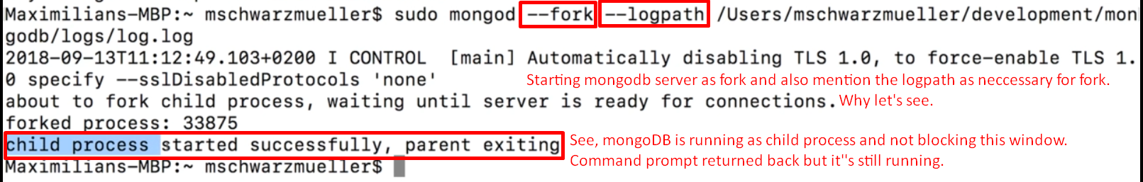
5. Now mongodb is running as **background service** not as **foreground process**.
6. As it is running as background service, it can’t log errors or warnings to that front screen (Terminal). It will write all the logs in the log file under the path we described.
7. How to run mongodb server on windows:
   1. During the installation, check the “as service”.
   2. Quit all existing processes in all your command prompts.
   3. Run CMD as admin.
   4. Command 🡺 net start mongodb.
8. How to quit this background service.
9. Mac: Command to stop mongodb background service.
   1. Switch to admin database ( use admin) then db.shutdownServer();
10. Windows: Comamnd to stop mongodb background service.
    1. Same as on mac.
    2. Open CMD as admin then 🡺 net stop mongodb.